Evanston Lighthouse
Rotary Club

2019
Holiday Sale
Guide

October 2019 – ver. 1
Holiday Sale Guide
Table of Contents
Topic Page
Purpose of the Holiday Sale 2
Holiday Sale Organization 3
Top Ten Sales Tips 3
Holiday Sale Website 4
Suggested Sales Letter 4
Holiday Sale Ordering Instructions 5
Credit Card Payments……………………………………………………………………...6
Schedule 8
Distribution Site Location Maps……………….………………………………………….9

Purpose of the Holiday Sale
The Holiday Sale is a major fundraiser for our club! Each year, beginning in October, the club sells high quality poinsettias, wreaths, citrus fruit, spiral cut hams, pecans, coffee, trail mix, and dark chocolate cranberries for holiday celebrations and gifts.

Each year the proceeds from the Holiday Sale are used to fund a number of community and international organizations and projects. This can be used as a handout or enclosure with the order form. This is why our Holiday Sale needs to be a success. More information about our beneficiary organizations and projects can be reviewed at the club’s website – www.evlrc.org.

Each club member needs to participate for the club to meet its fundraising and community service goals. As our customer base expands and our proceeds grow, we can help our community and international service funding meet growing needs. The more we sell, the more we earn, and the more we can help.

2018 Holiday Sales Organization
The following members serve as the Holiday Sale Committee. Feel free to contact any of them to ask questions about products, materials or procedures.

General and Finance Manager: Marisa Naujokas - 847-977-1336 marisanaujokas@gmail.com
Volunteer Manager: Steve Steiber – 847-867-1123 ssteiber@creativecaremanagement.com
Flower/Greenery Product Managers: Steve Carlson - (312) 404-3150 sc.carlson@sbcglobal.net
Kassandre McGovern kmcgovern3@luc.edu
Pecan Product Manager: Kate Collinson - (847) 910-1704 kate.collinson@comcast.net
Citrus Product Manager: Lesley Peters - (813) 361-9271 lesleypeters@qcommservices.com
Coffee/Pecans Product Manager: Jean Saunders - jesaunders1@gmail.com
Ham Product Manager: Bill Vernon – (312) 961-3303 bvernon@comcast.net and Steve Steiber
Trail Mix/Cranberries Manager: Steve Goranson - (773) 899-6970 goranson.stephen@gmail.com
Business/Order Manager: Joan Borg - (847) 420-8581 borgjoan@gmail.com
Information Systems Managers: Joan Borg and Bruce Baumberger (847-370-3515 gov.bruce@rotary6440.org)
Distribution Support: Susan Prout (847-363-1121 swprout@comcast.net)
Special Volunteers Who Will Sign Up at the Appropriate Time:
- Order Entry Processors (Helping Joan Borg)
- Distribution Helpers @ Clesen Wholesale (on 11/30, 12/5, 12/7 (primary pickup date), 12/11 and 12/14)
- Distribution Helpers @ Evanston Subaru (on 12/14)

Top 10 Sales Tips
- Prepare and prioritize your prospective customer list (October 15-31).
- Previous year customers first, high priority new prospects second, all other prospects third.
- Prepare and send letter or email to your entire list (October 20-November 5).
- Use email, Facebook, or USPS – your choice. If sending electronically, include the fillable pdf order form with the brief instruction to save the file to their hard drive first.
- Use the supplied general letter or prepare your own more personalized one.
- Emphasize community benefits.
- We support local organizations and projects that benefit Evanston families and children.
- Mention our international efforts in support of Rotary’s world-wide objectives.
- We also support Rotary International’s programs and project to promote health, education, world peace and understanding, and RI’s signature program to eradicate polio.
- Call or visit each prospect (top down) (by November 15).
- Follow up to obtain their order and to arrange for pickup or delivery.
- Sell benefits and ease of participation and overcome objections.
- “This sale helps a lot of families and children in need in Evanston and internationally”
- “We will deliver directly to your door – when you want”
- “We take credit cards”
- “We can handle and encourage gifts and donations”
- Obtain other leads and prospects - Business, Family, Neighbors.
- Customers often suggest others who might be interested in sale items. Also, carry Order Forms and Holiday Sale flyer with you to hand them out at parties and meetings. Always “ask for an order.”
- Suggest add-ons (fruit w/flowers, fruit w/ ham etc.) to past customers.
- One more poinsettia or one more box of oranges will help to build order size.
- Mention the new dark chocolate-covered cranberries.
- Suggest making a tax-deductible food gift to an Evanston shelter or food bank or a direct donation to our club foundation – and we will handle delivery. (Cash donations are tax deductible.)
- Send a thank you note.

Club Holiday Sale Website
Important information about the Holiday Sale is posted on the club’s website (www.evlrc.org) in the members’ area, and also at the Holiday Sale website at www.evlrc.net. All forms are available on the Holiday Sale website.

Sample Sales Letter/Email

October __, 2018

Dear ________, (or Friends and Neighbors),

Fresh Citrus, Hearty Hams, Pecans & Trail Mix, Poinsettias, Cyclamens, Amaryllis and Wreaths

That’s right, it’s time for Evanston Lighthouse Rotary Club’s annual Holiday Sale to raise money for that will directly benefit many Evanston residents, particular children.

Over the past 35 years the Evanston Lighthouse Rotary Club has donated more than $500,000 to local organizations, benefiting thousands of families and children in need in our community. This year these people need your help more than ever. Enjoy fresh Florida citrus, holiday hams, pecans and beautiful poinsettias, cylamens, amaryllis or wreaths and you will help raise money to support them. These are items most of us normally purchase during this time of year, and since our club sale is run by volunteers, 100% of the net proceeds go directly to charitable programs.

Something to consider: order one of our holiday items to be delivered to your favorite Evanston area charity (a homeless shelter, for example), and we can deliver it for you with your personal message. You will receive a receipt for your paid order, which would then be 100% tax deductible for you if the recipient is a charity (please consult your tax professional). An early order is appreciated to help determine charity delivery volunteers and schedules.

To place your order simply call me or fill out the attached order form and return it to me. I’ll deliver the items to you at a mutually convenient date in early December. Hams and pecans can be available before Thanksgiving with an early order. Poinsettias are available from mid-November on.

Thank you for your support (OR continued support in the case of past customers).

Happy Holidays,

Rotarian’s Name
Personal Email address
Personal Phone #

Holiday Sale Ordering Instructions
Each Rotarian is responsible for completing and submitting an Order Form for each of his/her customer’s orders. Please get your completed orders into the system promptly. It is not an official order until it has been entered into the system and it is easy to misplace an order.

Orders can be submitted in four ways:
METHOD 1: Enter them yourself using the Holiday Sale website at www.evlrc.net (recommended method). To use this method you must be trained and be issued a password – contact Joan Borg borgjoan@gmail.com or (847) 420-8581 for assistance. Please follow these instructions for online order entry:
  - Go to www.evlrc.net
  - Enter your username and password. Your username is your first initial plus last name. You'll be issued a unique password.
  - You will land on your own home page that shows your orders.
  - On the left-hand menu, click "Enter new order". You'll be taken to the order entry page.
  - Enter a batch ID for this order. The batch ID is used to group your orders into batches so you can see a summary report of what you have entered on a particular day. By default the batch ID begins you’re your username – add a sequence number to your username to create a batch, for example, "jdoe01".
  - Select the customer for this order. You can search the list of existing customers by typing part of the customer's name or address into the search box, and then press ENTER or click the button. Matching customers will be listed for you. Select the customer from the list, or if your customer is not on the list, click the "Add new customer" button. Remember to "Save changes" after you add a customer. You can return to the order entry page after adding the new customer.
  - If you find the customer in the list but need to update some of the customer's information, select the customer and click the "Edit customer" button. Remember to "Save changes" after you edit a customer. You can return to the order entry page after editing the customer.
  - Next you must select the Rotarian for this order. Click one of the letters shown to display the Rotarians whose last name begins with that letter. Select the Rotarian from the list.
  - Change the flower or food pickup dates and types if necessary. The primary pickup dates are shown by default. NOTE: Note that there are limited alternative dates for floral pick up. Check the order form for your choices.
  - For each product on the order, select the product and enter the quantity ordered. Add any special instructions for the product's handling.
  - Click "Save changes" to save the new order. You will be taken to the order confirmation screen. Check the data on the screen and if it needs correction, click "Edit this order" to make changes. Since the online order form allows you to enter only five items at a time, click "Edit this order" to add more items to your order.
  - After completing your order, print a copy of the Order Confirmation form to turn in at the next club meeting. If there is a check that goes with the order, paper clip the check to the order confirmation form and write the check number at the bottom of the form, in the lower right hand corner. Please also record your initials and the date entered on the form. Also be sure to handwrite, in the upper right hand corner of the customer’s check, the order number shown on the sale confirmation. See note about credit card payments below.
  - Hand deliver the printed, order confirmation forms to a club meeting by placing them in the cardboard box on the Club Secretary’s table, marked as entered only if you’ve entered the order in the system.
Questions? Please contact Joan Borg (borgjoan@gmail.com (847) 420-8581) or Bruce Baumberger (gov.bruce@rotary6440.org (847)370-3515).
METHOD 2: Bring order forms to each Tuesday morning meeting for Joan Borg to enter. Place the completed Order Forms, along with any payments attached, in the special Order Form box on the sign-in table or give them directly to Joan Borg. Order processing needs to proceed as quickly and orderly as possible. Please avoid this method as best you can to avoid overtaxing Joan. Ask her for help entering if needed (see above).

METHOD 3: Email orders or order forms to Joan Borg. If you have been paid by check, write the check number on the bottom of the form before emailing to Joan. Bring checks to the meeting to put in the order box, and make sure it is clear which order the check is for and that the order was already placed! Keep the original order form for your records. If you have emailed the order form, do not bring the order form to the meeting to prevent duplicate orders entered in our system.

METHOD 4: Mail the order form and payment to Marisa Naujokas via US Postal Service. Her address is 1108 Maple Ave, Evanston IL, 60202. Factor in 2-3 business days for delivery.
CREDIT CARD PAYMENTS: To make payments via credit card, there are two options: credit card details can be called in or entered on the order form for Joan to process. 1) To call in, you or the customer can email us at info@evanstonrotaryholiday.org and provide the customer name and phone number. The customer will be contacted to provide the credit card information verbally. 2) To write the credit card information, be sure to get ALL information requested including ZIP Code and write clearly. Submit the form in an envelope.
Please get your completed orders into the system promptly. It is not an official order until it has been entered into the system and it is easy to misplace an order.
Copies of the order form are available on the club’s regular website (www.evlrc.org) – look on the homepage, left column, document downloads section. Download the fillable PDF version of the Order Form to tailor/personalize it for your use (your name, phone, fax, etc.). Be sure to instruct customers to save the fillable PDF to their hard drive before filling it in. You may also download and print plain copies to be filled in manually.

All information must be entered on the Order Form – Important information to include:

Rotary Contact Information: Your telephone numbers and email address.
  - You are responsible for your orders – you will get a call if the form is not complete or if the form can’t be read.
  - Each Rotarian must keep a copy of each order form.

Customer Name and Address
  - Must be complete for future address labels- include Zip Code.
  - Complete first and last name (e.g., William Smith, not Willy Smith).
  - If a two last name family, please use the same name each year (or we will have two addresses for the same family).

Pickup date: Essential and Critical that the Date Must Be Included on All Order Forms!!!
  - Most important – be sure to include the pickup date on all orders – the primary (default) pickup date for floral products is December 7. The other dates are 11/30, 12/4, 12/11, and 12/14.
  - Hams, trail mix, cranberries, coffee, and pecan products may be ordered for delivery prior to Thanksgiving (for Thanksgiving).
  - Pre-Thanksgiving product orders should be entered into evlrc.net by 11/7 and products can be picked up and delivered by the Rotarian on 11/23. We have some flexibility with some products so contact an HS team member if you have Thanksgiving orders after Nov. 7.
  - Pre-Thanksgiving orders must be on a separate order form from regular delivery orders for a given customer.
  - The primary delivery date for hams, citrus, trail mix, cranberries, and pecan products is December 14.
  - There can be some flexibility for additional delivery dates for trail mix, cranberries, coffee, and pecan products throughout the sale. Check with Kate Collinson or Marisa Naujokas if you have questions.
  - We can make some accommodations for large orders, such as direct delivery of a large pecan order to a business location.
- Method of payment needs to be marked on the Order Form, and all checks or cash received at the time of the order needs to accompany the completed form(s) when you turn in your form at a club meeting or mail it to Marisa.

Credit card payments – See details about credit card payments on Page 6. Method 1: you or the customer can email us at info@evanstonrotaryholiday.org and provide the customer name and phone number. The customer will be contacted to provide the credit card information verbally. Method 2: print information very clearly on the order form including all credit card details including the ZIP Code and CVV code. Your customer’s statement will identify Evanston Lighthouse Rotary Holiday Sale as the vendor. Please put forms with credit card information in an envelope to deliver in the box at the club meeting.

For flowers/greenery at Clesen’s, there are some very important timing rules:
- If you are entering your own orders on the Holiday Sale website, the order must be in the system three days before you want to pick it up.
- If you are depending on the committee to enter your order, you must email it or give it to Joan Borg four days before the day you want to pick it up. Call Steve Carlson ((312-404-3150) if you have questions about last minute orders. The Rotarian will be sent an email notice of their pickups the day before they are to occur.
- Note: All Flowers/Greenery orders must be picked up on the date stated on the Order Form. If you need to make a change, there are two ways to make the change:
- If you are entering your orders on the Holiday Sale website, go into the system at least three days before the pickup date and pull up the order and change the date to a later date.
- Ask Joan Borg to change the date at least three days before the pickup date on the order. If you don’t have that much time, contact Steve Carlson.

2019 SCHEDULE
Event | Category | Ham | Citrus | Pecans/ Coffee | Trail Mix /  Cranberries | Greenery
Orders for Thanksgiving Due | Food | Nov 7 | -- | Nov 7 pecans/ Nov 18 coffee | Nov 7 | --
First Food Delivery / Thanksgiving |  | Nov 23 | -- | Nov 23  (flexible and ongoing) | Nov 23  (flexible and ongoing) | --
Orders for December food delivery date |  | Dec 1 | Dec 1 | Dec 4 | Nov 29 | --
Major food delivery day |  | Dec 14 | Dec 14 | Dec 14  (flexible and ongoing) | Dec 14  (flexible and ongoing) | --
First floral delivery day | Floral / Greenery | -- | -- | -- | -- | Nov 30*
Second weekday floral day |  | -- | -- | -- | -- | Dec 4*
Major floral delivery day |  | -- | -- | -- | -- | Dec 7*
Alternate and final floral delivery |  | -- | -- | -- | -- | Dec 11* Dec. 14
*Your order for floral/greenery must be in the system at least 36 hours prior to when you want to pick it up because Clesen’s pulls the order the morning before pickup
General Manager: Marisa Naujokas - 847-977-1336 marisanaujokas@gmail.com
Volunteer Manager: Steve Steiber – 847-867-1123 ssteiber@creativecaremanagement.com
Greenery Product Managers: Steve Carlson - (312) 404-3150 sc.carlson@sbcglobal.net
and Kassandre McGovern kmcgovern3@luc.edu
Pecan Product Manager: Kate Collinson - (847) 910-1704 kate.collinson@comcast.net
Coffee and Pecans: Jean Saunders jesaunders1@gmail.com
Citrus Product Manager: Lesley Peters - (813) 361-9271 lesley.peters@gmail.com
Ham Product Manager: Bill Vernon – (312) 961-3303 bvernon@comcast.net
Trail Mix/Cranberries Manager: Steve Goranson - (773) 899-6970 goranson.stephen@gmail.com
Business/Order Manager: Joan Borg - (847) 420-8581 borgjoan@gmail.com
Information Systems Managers: Joan Borg (847) 420-8581 borgjoan@gmail.com
and Bruce Baumberger (847) 370-3515 gov.bruce@rotary6440.org)

Clesen’s Wholesale – Flower and Wreath Pickup Site
Pick up scheduled for December1, 9:00 AM to Noon

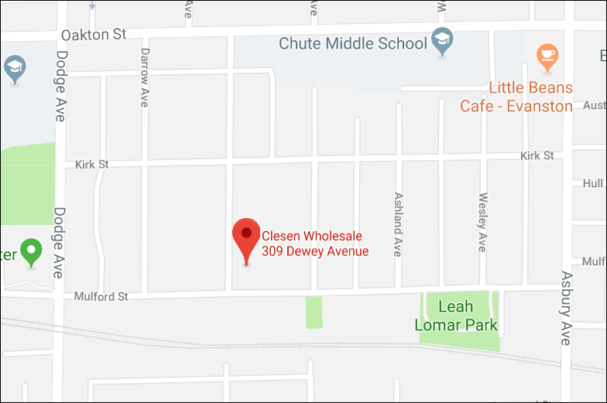

Evanston Subaru– Fruit, Ham, Nut Pickup Site
Pick up scheduled for December 15, 9:00 AM to Noon

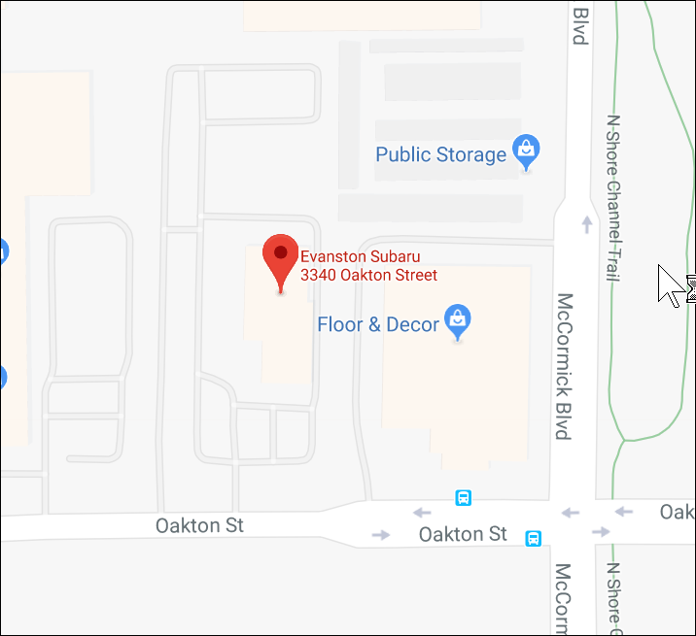

Note: Look for the Rotary pickup signs.

